**Stata Final Project**

The author has selected National Health and nutrition examination survey 2017-March 2020 data for the Stata class final project. This NHANES dataset was first published in August 2021.

The dataset contains the medical conditions which are self and proxy-reported personal interview data on a broad range of health conditions and medical history.

**Research Question**

Overweight people are more susceptible to the diseases like asthma, cancer and liver disease.

**Outcome Variable (Binary)**

* Overweight (mcq080)

**Independent Variable (Binary)**

* Asthma (mcq010)
* Cancer(mcq220)
* Liver disease(mcq500)

**Introduction**

Increased body weight or obesity is a public health concern for all ages.1 Obesity in adults is defined as a Body Mass Index of ≥30kg/m2.1 Being overweight is linked to chronic diseases like asthma, cancer and liver diseases.1,2 Prevalence of asthma in adults with lean body type is 7.1% and in those obese is 11.1%.1 meta-analysis reports that obesity is associated with an increase in primary liver cancer in males and females.2

**Methodology**

After selecting the outcome variable and the relevant independent variable to look for the association and correlation between the outcome variable overweight to asthma, cancer and liver disease, dropped irrelevant responses (Don’t know), recorded all the variables, labelled the responses and finally renamed the variable name for ease. Now data is ready for descriptive and exploratory analysis as well as regressions. All the coding and analysis are done using StataSE17(64-bit) having Washington university in st. louis access.

**Results**

**Descriptive Statistics**

The cross table indicates 431 (11.91%) responded as being overweight and having cancer both, while 3,187 (88.09%) reported that they are overweight and do not have malignancy, which is statistically significant p<0.05. For asthma 765 (19.84%) reported being overweight as well as asthmatic while 3,091 (80.16%) were overweight but had no asthma, which is statistically highly significant p<0.001. Only 6 (2.52%) people responded as having a liver condition and being overweight, however, 232 (97.48%) reported that they had no liver condition and are overweight, which is statistically highly significant p<0.001.

Graphical Representation of outcome and the independent variable

**Figure-1 Bar graph of asthma by overweight.**

Figure-1 represents 53.1% of asthmatic people are obese while 63.8% of non-asthmatic people are overweight.

**Figure-2 Bar graph cancer by overweight.**

Figure-2 represents 57.0% of cancerous people are obese while 61.2% of non-malignant people are overweight.

**Figure-3 Bar graph of the liver condition by overweight.**

Figure-3 represents 14.3% of people with liver complications are obese while 75.6% of people without liver disease are overweight.

**Logistic Regression output:**

|  |  |
| --- | --- |
| Iteration 0: log likelihood = -6169.1922  Iteration 1: log likelihood = -6127.691  Iteration 2: log likelihood = -6127.6575  Iteration 3: log likelihood = -6127.6575 | Logistic regression  Number of obs = 9,207  LR chi2(2) = 83.07  Prob > chi2 = 0.0000  Log likelihood = -6127.6575  Pseudo R2 = 0.0067 |

**Table-1 logistic regression result for overweight by asthma and cancer**

|  |  |
| --- | --- |
| Variables | Logit |
| Doctor ever said you were overweight |  |
| Ever been told you have asthma = 1, no | 1.660*** |
|  | (0.096) |
| Ever told you had cancer or malignancy = 1, no | 1.177** |
|  | (0.080) |
| Constant | 0.874* |
|  | (0.070) |
| Observations | 9,207 |
| pesudo R2 | 0.00673 |
| seEform in parentheses |  |
| *** p<0.01, ** p<0.05, * p<0.1 |  |

**Table-2 Independent variable and logit model odds ratio with p value**

After controlling for other variables cancer overweight people are 1.66 as likely to not have asthma, as opposed to lean people, which is highly significant p<0.01.

After controlling for other variables asthma overweight people are 1.17 as likely to not have cancer, as opposed to lean people, which is highly significant p<0.05.

**Pseudo R-square is 0.00673**

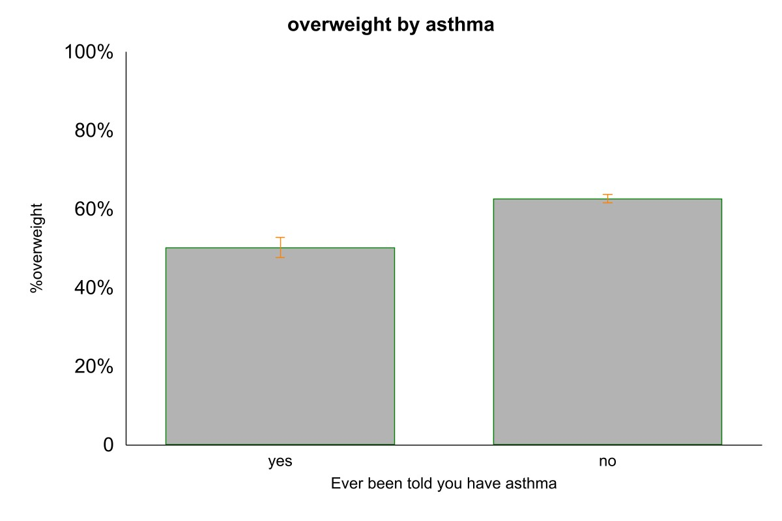

**Figure-4 Regression model graph of overweight by asthma**

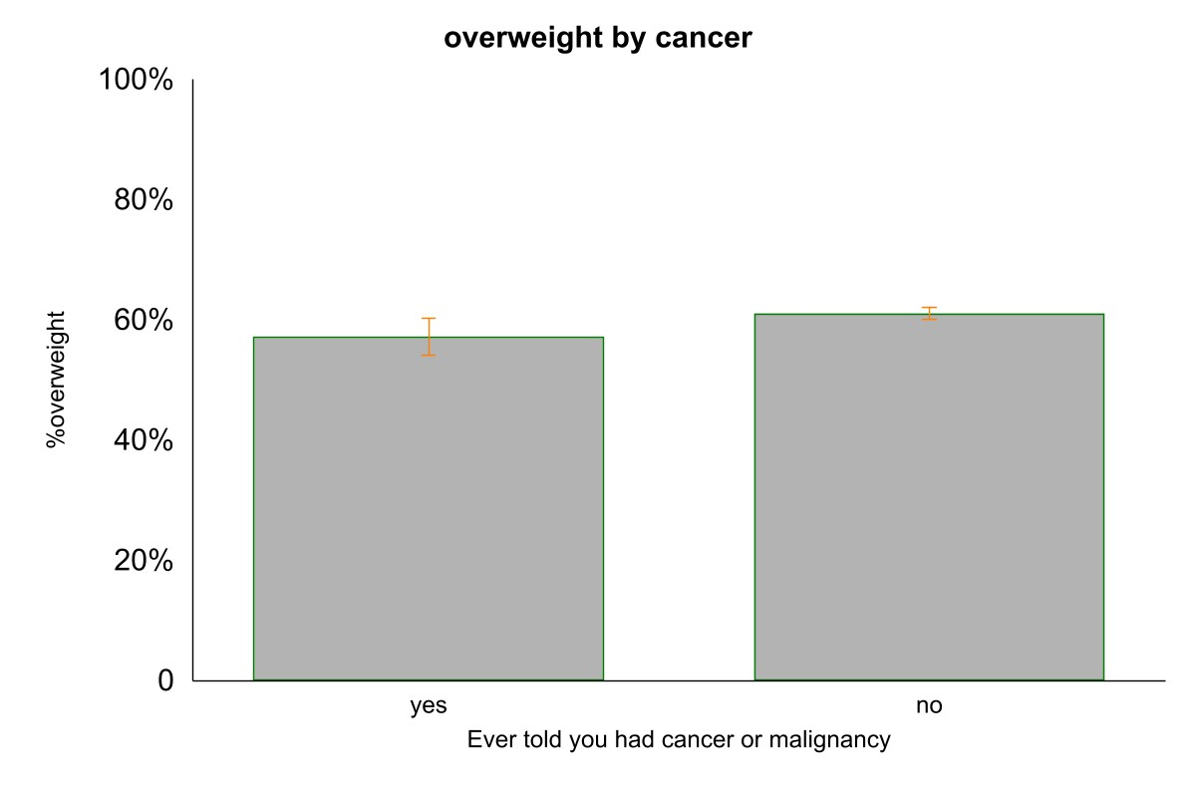

**Figure-5 Regression model graph of overweight by cancer**

**Conclusion**

This project and data analysis supplement the existing literature that obese people are associated with chronic diseases like cancer, asthma and liver conditions. Chi-square test results show these associations are statistically significant.

Regression output for cancer and asthma with overweight inferences reveals that overweight is 1.66 and 1.17 as likely to not have asthma and cancer as opposed to the non-obese persons.

**Limitations**

There were not enough relevant data for the positive outcome of interest to run regression models, for example, overweight with the liver condition were only 6 people.

**Future Study**

Studies related to chronic health conditions with the outcome variable related to lifestyle factors can be studied to emphasize the importance of lifestyle benefits on the health and economy using large datasets like BRFSS.

**REFERENCES**

1. Peters U, Dixon AE, Forno E. Obesity and asthma. *Journal of Allergy and Clinical Immunology*. 2018;141(4):1169-1179. doi:[10.1016/j.jaci.2018.02.004](https://doi.org/10.1016/j.jaci.2018.02.004)
2. Chen Y, Wang X, Wang J, Yan Z, Luo J. Excess body weight and the risk of primary liver cancer: an updated meta-analysis of prospective studies. *Eur J Cancer*. 2012;48(14):2137-2145. doi:[10.1016/j.ejca.2012.02.063](https://doi.org/10.1016/j.ejca.2012.02.063)